**Abstract**

*Predictive analytics is the use of data, statistical algorithms and machine learning techniques to identify the likelihood of future outcomes based on historical data. The goal is to go beyond knowing what has happened to providing a best assessment of what will happen in the future. Predictive analysis is an advanced branch of data engineering which generally predicts some occurrence or probability based on data. Predictive analytics uses data-mining techniques in order to make predictions about future events, and make recommendations based on these predictions. The process involves an analysis of historic data and based on that analysis to predict the future occurrences or events. A model can be created to predict using Predictive Analytics modeling techniques. The form of these predictive models varies depending on the data they are using. Classification & Regression are the two main objectives of predictive analytics. Predictive Analytics is composed of various statistical & analytical techniques used to develop models that will predict future occurrence, events or probabilities. Predictive analytics is able to not only deal with continuous changes, but discontinuous changes as well. Classification, prediction, and to some extent, affinity analysis constitute the analytical methods employed in predictive analytics.*

**CHAPTER ONE**

**1.1 INTRODUCTION**

Predictive analytics is composed of two words predict & analysis, but it works in reverse viz. first analyze then predict. It is human nature to want to know and predict what the future holds. Predictive analytics deals with the prediction of future events based on previously observed historical data by applying sophisticated methods like machine learning. The historical data is collected and transformed by using various techniques like filtering, correlating the data, and so on. Prediction process can be divided into four steps: (1) collect and pre-process raw data; (2) transform pre-processed data into a form that can be easily handled by the (selected) machine learning method; (3) create the learning model (training) using the transformed data; (4) report predictions to the user using the previously created learning model. Marketing as a discipline involves researching and developing a product and facilitating its sale and distribution to the general public. The concept of marketing has existed since long and is changing as per the needs and purchasing behaviors of consumers. Thus, today’s marketing is very different from what it used to be a few decades ago, mainly due to a rapidly changing world economy and the advancement in the technology, which together led to free and speedy knowledge distribution and exchange. Nowadays, large quantities of data are being accumulated. The amount of data collected is said to be almost doubled every 9 months. Seeking knowledge from massive data is one of the most desired attributes of Data Mining. Usually there is a huge gap between the stored data and the knowledge that can be constructed from it (laura, 2010). Due to the huge amount of information related to customers and daily purchase transactions, the businesses databases are dramatically increased and become huge. For this reason, knowledge management and data mining (DM) techniques and tools have become important for the marketing decisions. DM can be used to extract useful information of hidden purchase patterns that could be used to support the marketing decisions. Also, DM can help to analyze the overall market (Xie, 2010).

**1.2 STATEMENT OF PROBLEM**

There are so many options, tasks, techniques, tools, formats, and approaches to data mining that marketers find it very difficult to design and implement projects. Although methodologies already exist, they are designed for specific software packages. Most of these methodologies use a traditional statistical approach. It is still not clear that this approach to data mining is sufficient for obtaining the vast array of data needed for industrial applications. Thus, a data mining methodology to meet the specific requirements of marketers is needed. Such a methodology should assist industries in selecting appropriate data mining tools and implementing data mining projects from a systems perspective.

**1.3 AIMS AND OBJECTIVES**

The primary aim of this study is to create a system that uses data mining technique to identify marketing progress.

The objectives include:

* To build a prototype of data mining system that extract useful information of hidden purchase pattern.
* To identify and predict outcomes of possible market strategies.
* To predict trends and products that customers would be interested in
* To understand buying habit of targeted audience

**1.4 SCOPE AND LIMITATION**

A system that uses data mining technique to extract useful and hidden information from large dataset, to predict current trend and allowing businesses to make proactive, knowledge driven decisions. This study focuses specifically on applying data mining to problems in making strategic marketing planning. It emphasizes the application of a systems analysis and design perspective to develop a data mining methodology suitable for those applications. Only the information necessary to illustrate the concepts described in this study have been included. For that reason, requirements necessary for the application of data mining in other fields have been omitted.

**1.5 SIGNIFICANCE OF THE STUDY**

Marketing decisions are very important for any organization to increase the profit. It. Marketing is becoming more difficult every day. Nowadays, the business environments are more complex. Marketing decisions are restricted by the surrounding of the society. For this reason, marketing decision should be standardized which will help marketers to do the business in a professional way. To make any marketing decision more accurate, some tools and technique should be used. Data mining is important tool to support marketers, study show that data mining can improve marketing significantly.

**1.6 METHODOLOGY**

The methodology proposed in this study is an abstract and functional framework. It is a conceptual model, it has not been implemented yet, and therefore it has not been executed or tested. That task remains for the future

**CHAPTER TWO**

**LITERATURE REVIEW**

With big data becoming more prevalent in the business world, a lot of data terms get thrown around, with many not quite understanding what they mean. What is data mining? Is there a difference between data mining and predictive analytics? How are the two related? All of these are great questions and discovering their answers can provide a deeper insight into using data science to benefit your company.

If you are hoping to effectively leverage web data to increase business opportunities by forecasting upcoming trends, understanding the various terms used in web data is crucial. Both data mining and predictive analytics, powerful processes that help in establishing powerful data-driven decisions, are two terms used quite often and even sometimes are used interchangeably within data science. But it’s important to note, predictive analysis goes [beyond](https://www.datasciencecentral.com/profiles/blogs/differences-between-data-mining-and-predictive-analytics)data mining from predicting what might happen next using existing data sourced from data mining.

## 2.1 What is data mining?

Data mining is basically the process of analyzing large sets of data to find patterns, relationships, and trends that otherwise might be missed through more traditional analysis methods. It is used to uncover shared similarities or groupings in web data that help gain insights for business decisions.

Data mining is used for a variety of different purposes, including financial research where it is used by investors to look at a start-up’s financials to determine if they want to offer funding. It is also used to collect data on sales trends to better inform everything from marketing to inventory needs, in addition to securing new leads. Data mining is used to comb through social media profiles, websites, and digital assets to compile information on a company’s ideal leads to start an outreach campaign.

## 2.2 What is predictive analytics?

Predictive analytics uses mathematical algorithms and machine learning to identify how likelihood something will occur in the future based on patterns of previous data. The goal of predictive analytics is to use past knowledge of what has happened to provide a better idea of what to expect in the future.

## 2.3 What is the difference between data mining and predictive analytics?

Well both data mining and predictive analytics use algorithms to discover new insights to find the best business solutions. The data mining process is heavily based on algorithms to analyze and extract information that automatically discovers hidden patterns and relationships within the data.

Within predictive analytics, the process uses data patterns to make predictions with machine learning. Machines take both historical and current information and it is then applied to a model that predicts future trends. The biggest difference between the two is that data mining explores the data but predictive analytics takes it a step further by telling you what will happen next.

## 2.4 The benefits of predictive analytics to businesses

Using predictive analytics with data sourced with data mining is a powerful way to help project what may happen later on in the business, allowing leaders and key decision makers to plan accordingly. It makes looking into the future more accurate and reliable than previous tools.

Organizations today are using predictive analytics in almost every [industry](https://www.import.io/post/industries-web-data-integration-improving-wdi-use-cases/). Technology like Import.io’s [web data integration](https://www.import.io/web-data-integration/) give companies the tools to be able to predict various types of consumer behavior and patterns, and how to appropriately prepare according to business needs. Retailers use it to forecast inventory to efficiently maximize sales. [The travel industry](https://www.import.io/solutions-briefs/online-travel/) frequently uses predictive models from past travel trends to set ticket prices and hotel rates.

With [80% of all web data being unstructured](https://www.ibm.com/blogs/watson/2016/05/biggest-data-challenges-might-not-even-know/), predictive analysis tools can help make sense of all that data while providing valuable insights for businesses. This allows businesses to learn which solution to take for the best possible outcome from previous logical data that has been captured and then helping predict the future.

**2.5 PREDICTIVE ANALYTICS PROCESS**

Predictive analytics involves several steps through which a data analyst can predict the future based on the current and historical data.

**2.5.1 Requirement Collection**

To develop a predictive model, it must be cleared that what is the aim of prediction. Through the prediction, the type of knowledge which will be gained should be defined. For example, a pharmaceutical company wants to know the forecast on the sale of a medicine in a particular area to avoid expiry of those medicines. The data analysts sit with the clients to know the requirement of developing the predictive model and how the client will be benefitted from these predictions. It will be identified that which data of client will be required in developing the model.

**2.5.2 Data Collection**

After knowing the requirement of the client organization, the analyst will collect the datasets, may be from different sources, required in developing the predictive model. This may be a complete list of customers who use or check the products of the company. This data may be in the structured form or in unstructured form. The analyst verifies the data collected from the clients at their own site.

**2.5.3 Data Analysis and Massaging**

Data analysts analyze the collected data and prepare it for analysis and to be used in the model. The unstructured data is converted into a structured form in this step. Once the complete data is available in the structured form, its quality is then tested. There are possibilities that erroneous data is present in the main dataset or there are many missing values against the attributes, these all must be addressed. The effectiveness of the predictive model totally depends on the quality of data. The analysis phase is sometimes referred to as data munging or massaging the data that means converting the raw data into a format that is used for analytics.

**2.5.4 Statistics, Machine Learning**

The predictive analytics process employs many statistical and machine learning technique. Probability theory and regression analysis are most important techniques which are popularly used in analytics. Similarly, artificial neural networks, decision tree, support vector machines are the tools of machine learning which are widely used in many predictive analytics tasks. All the predictive analytics models are based on statistical and/or machine learning techniques. Hence the analysts apply the concepts of statistics and machine learning in order to develop predictive models. Machine learning techniques have an advantage over conventional statistical

techniques, but techniques of statistics must be involved in developing any predictive model.

**2.5.5 Predictive Modeling**

In this phase, a model is developed based on statistical and machine learning techniques and the example dataset. After the development, it is tested on the test dataset which a part of the main collected dataset to check the validity of the model and if successful, the model is said to be fit. Once fitted, the model can make accurate predictions on the new data entered as input to the system. In many applications, the multi-model solution is opted for a problem.

**2.5.6 Prediction and Monitoring**

After the successful tests in predictions, the model is deployed at the client’s site for everyday predictions and decision-making process. The results and reports are generated by the model nor managerial process. The model is consistently monitored to ensure whether it is giving the correct results and making the accurate predictions. Here we have seen that predictive analytics is not a single step to make predictions about the future. It is a step-by-step

process which involves multiple processes from requirement collection to deployment and monitoring for effective utilization of the system in order to make it a system in decision-making process.

**2.6 PREDICTIVE ANALYTICS OPPORTUNITIES**

Though there is a long history of working with predictive analytics and it has been applied widely in many domains for decades, today is the era of predictive analytics due to the advancement of technologies and dependency on data. Many organizations are tending towards predictive analytics in order to increase their bottom line and profit. There are several reasons for this attraction:-

* Growth in the volume and types of data is the reason to use predictive analytics to find insights from large-sized data.
* Faster, cheaper, and user-friendly computers are available for processing
* A variety of software is available and more developments are going on in software which are easy to use for users.
* The competitive environment of growing the organization with profit and the economic conditions of the organization push them to use the predictive analytics.

With the development of easy to use and interactive software and its availability, predictive analytics is not being limited to the statisticians and mathematicians. It is being used in a full swing by business analysts and managerial decision process. Some of the most common opportunities in the field of predictive can be listed as:-

**1. Detecting Fraud:** Detection and prevention of criminal behavior patterns can be improved by combining the multiple analysis methods. The

growth in cybersecurity is becoming a concern. The behavioral analytics may be applied to monitor the actions on the network in real time. It may identify the abnormal activities that may lead to a fraud. Threats may also be detected by applying this concept.

2. **Reduction of Risk:** Likelihood of default by a buyer or a consumer of a service may be assessed in advance by the credit score applying the predictive analytics. The credit score is generated by the predictive model using all the data related to the person’s creditworthiness. This is applied by credit card issuers and insurance companies to identify the fraudulent customers.

**3. Marketing Campaign Optimization:** The response of customers on purchase of a product may be determined by applying predictive analytics. It may also be used to promote the cross-sale opportunities. It helps the businesses to attract and retain the most profitable customers.

**4. Operation Improvement:** Forecasting on inventory and managing the resources can be achieved by applying the predictive models. To set the prices of tickets, airlines may use predictive analytics. To maximize its occupancy and increasing the revenue, hotels may use predictive models to predict the

number of guests on a given night. An organization may be enabled to function more efficiently by applying the predictive analytics.

5. **Clinical Decision Support System:** Expert systems based on predictive models may be used for diagnosis of a patient. It may also be used in the development of medicines for a disease.

The predictive analytic model is defined precisely as a model which predicts at a detailed level of granularity. It generates a predictive score for each individual. It is more like a technology which learns from experience in order to make predictions about the future behavior of an individual. This helps in making better decisions. The accuracy of results by the model depends on the level of data analysis.

**2.7 PREDICTIVE ANALYTICS TECHNIQUES**

All the predictive analytics models are grouped into classification models and regression models. Classification models predict the membership of values to certain class while the regression models predict a number. We will now list out the important techniques below which are used popularly in developing the predictive models.

**CHAPTER THREE: SYSTEM ANALYSIS AND DESIGN**

**3.1 Examination of Existing Work**

The existing method of predicting marketing strategy manually through sales forcast or product forecast is rigorous. Manual sales forecasting means that you are going to carry out all the required forecasting processes yourself. Here is what you need to know on how to forecast sales manually:

* Assess the Historical Trends: It’s always good to have statistical data regarding the sales of your past year at hand. Break down the numbers by price, product, sales period, etc. This way you might be able to project the past data into the future. This calculation can be done either by using certain corresponding tools or manually. The latter might be more advantageous, especially if it’s guided by analysis. Also, have a look at your past sales forecast examples if there are any, just to refresh your mind on where and how to start. Below is a graph that shows historical trends in a time series graph:

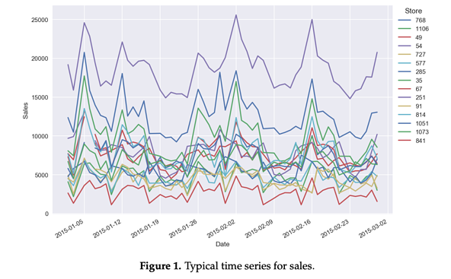

* Develop Unit Sales Projection: Start by forecasting unit sales per month if it’s possible for your product. It’s not only product-oriented businesses that sell in units, many service businesses do that as well. The forecasting process is much easier if you are able to break things down into their components.
* Use Factors for Your New Product: If your product is completely new with no history, an already existing similar product could work as a guide for your forecast.
* Collaborate with Your Sales Team: Manual forecasting will be much more productive if you manage to ensure solid teamwork with your sales representatives and customer service staff. Sales representatives have a deeper knowledge of your market which also includes information about your competitors. Customer service team can also contribute to the estimation of the potential of your new product. Discussing your new product or project with them you’ll get more precise numbers: e.g., the number of units you can move in the initial months or, the possible ramp-up rate.
* Talk to Other Professionals: Loyal customers, suppliers and sales partners (dealers or distributors) might be of great help in understanding the future success of your product.
* Do Your Own Market Research: Conduct surveys, determine focus groups and observe your target audience. This way you’ll have a better idea of the potential customer demand for your new product. Find out any existing sales forecast examples of products similar to yours and learn about their sales development processes. This, however, will take a lot of time, unless you decide to trust a professional.
* Choose Time Periods Wisely: Commonly, the sales and finance function may only be interested in monthly data. However, the first few days and weeks of the sales of your product are of crucial importance. Make sure to have detailed daily forecasts for at least the first quarter of your product sales in order to get more precise data and reach better results.
* Keep Track of Your Results and Adjust: Keep in mind to adjust your sales forecast as soon as you have the actual sales results. Never let loose of disciplined sales monitoring on a monthly basis. Keep track of product reviews, media mentions and customer feedback and discuss with your team all the required changes.

The manual execution of your predicting marketing strategy is quite a long and complex process, however, if done correctly, it will surely pay you back with good results. Some of the main advantages of manual forecasting are as follows:

* Free of Charge: Manual sales forecasting is technically free as you are doing it all on your own. However, this is not completely true as it will still require time investment from your employees whom you pay. They could be spending their time working on things that actually require human brain and cannot be substituted with a machine.
* Detailed Analysis: Human common sense is one of the best “tools” when it comes to thoroughly analyzing the market and the possible future sales of your new product.

**Manual product forecast comes with several drawbacks too:**

* Time-Consuming: Manual forecasting is quite a long process. The longer the time you spend working on sales forecasting, the higher the possibility of losing actual sales opportunities. Time is money!
* Biased and Inaccurate: As a business owner, you might not carry out a really objective sales forecast for your own product. It will eventually end up being biased and inaccurate.
* Erroneous Human Mind: Besides, the human mind can be erroneous and say, a single mistake in counting certain numbers will double your work

**3.2 Design of Proposed System**

The proposed system is machine-based, which helps to analyze and predict marketing strategies through Data-Mining. Machine-based marketing strategy prediction is becoming one of the top trends in supply chain as it’s come to improve customer engagement and generate much more accurate demand forecasts without human interference.

If you are wondering whether or not machine-based prediction is worth the investment, a list of its advantages displayed below will help you make the correct decision:

### **Data Segmentation**

The wealth of data which predictive analytics can provide helps marketers to see more angles on leads. Segmentation can become more sophisticated and marketing messages are given a laser focus. The roll on effect for marketing? Better campaign success and some real ownership over results.

### **Focused Spending**

With a general climate of greater accountability for marketing, justifying the marketing spend and being prepared to back it up well with data has become an expectation. Predictive analytics give marketers a more detailed view of where their customers are and how to focus marketing spend. Companies who are using predictive analytics to focus spending are often finding that they’re able to bring in more qualified leads for less overall spend because they’re able to remove a lot of guesswork.

### **Deal Acceleration**

In the Forrester survey mentioned earlier, 78% of respondents believe that the role of marketing has shifted from a predominant focus on demand generation. They believe the role really has expanded to include deal acceleration and more effectively engaging digitally with customers.

Predictive analytics feature as a top priority for marketers who are looking for effective tools to assist them in their expanded roles. This advanced analytics can help marketers to nurture the right leads and convert sales faster. They help [give marketing a seat at the decision-making table](https://koombea.com/blog/marketing-numbers-cmos-watching/).

## Confident Marketing Strategy

The biggest advantage to a marketing strategy that predictive analytics offers is that it allows businesses to take action and develop future initiatives based on data. It’s not a hunch, a gut feeling, or a click your heels together three times and hope for the best sort of thing. You’re making decisions that are informed by data, statistics and past behaviors.

Marketing can take their seat at the table with confidence, knowing that they are able to narrow down a targeted audience and justify their distribution and spend.

* **Unlimited Data**

Machine-based prediction combines big data, cloud computing and learning algorithms that enable the evaluation of millions of information using an unlimited amount of demand factors at once.

* **A Classier Approach**

Machine learning prediction uses the so-called pattern identification with a separate, broad array of algorithms that can become accustomed to all data and are suitable for numerous demand form categories. Below is an example of a time consuming algorithm if not used through machine learning.

* **Higher Accuracy Level**

As machine-based analysis uses more data, it makes the forecast more precise and accurate. Such points as product elements, wrapping, raw material valuing, third-party fiscal data and other relevant information that can be counted will be included in the forecast. Besides, automated software is much less error-prone than the human mind and the probability of stumbling upon a mistake with it is drastically low.

* **Control of the Whole Product History**

This automated method of marketing strategy prediction is also able to control the history of all products which also includes sales advancements and estimated demand.

As it becomes clear from the above-listed advantages, machine-based analysis is pretty much the most effective method for your new product forecasting. All you need to do is choose the right software and let it predict the future of your new product sales.

**CHAPTER FOUR**

**SYSTEM IMPLEMENTATION AND TESTING**

**4.1 DESIGN OF THE SYSTEM**

The proposed system is designed in forms, with all the forms working together to perform the goal to mine data and help predict the product that draws the most attention in order to create a marketing strategy to improve sales as earlier discussed in chapter three.

The ability to analyse and give focus to the system is explained in the following format which are output design, input design, database design, as well as the procedure design.

**4.1.1 OUTPUT DESIGN**

The output to be produced from this proposed system design program are:

1. Most Viewed Today

2. Monthly Top Sellers

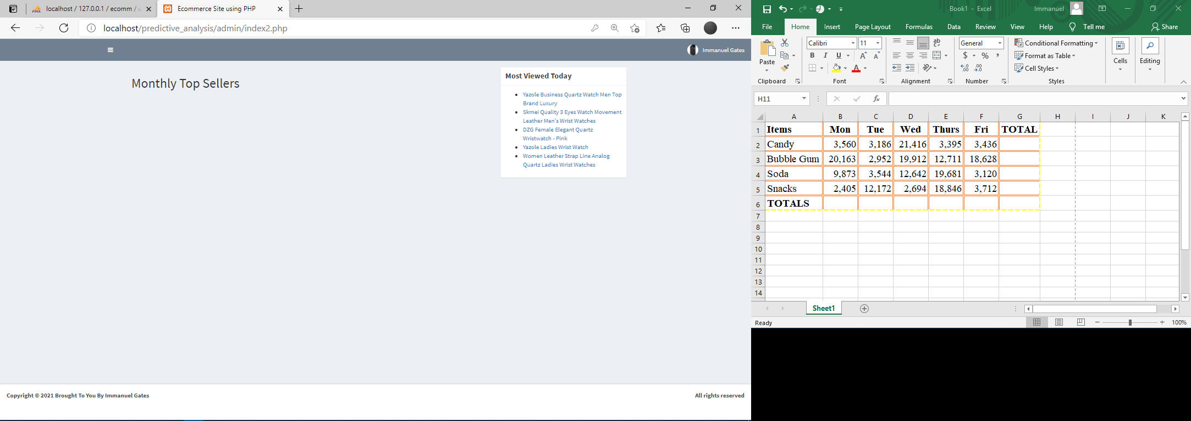

This Module displays to the admin the most viewed product for the day and the products that sold the most in a particular month. This helps the admin make strategic marketing decisions to keep the business growing.

**4.1.2 INPUT DESIGN**

The proposed system has the following as the input design:

1. The Product Purchase Page

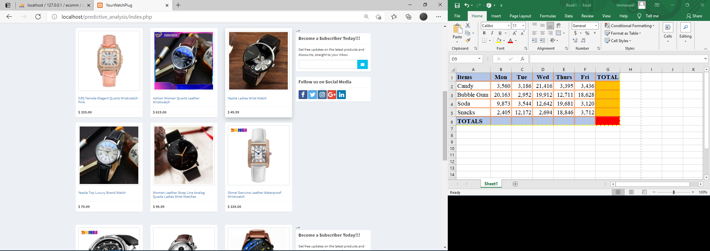

2. The Payment Platform Page

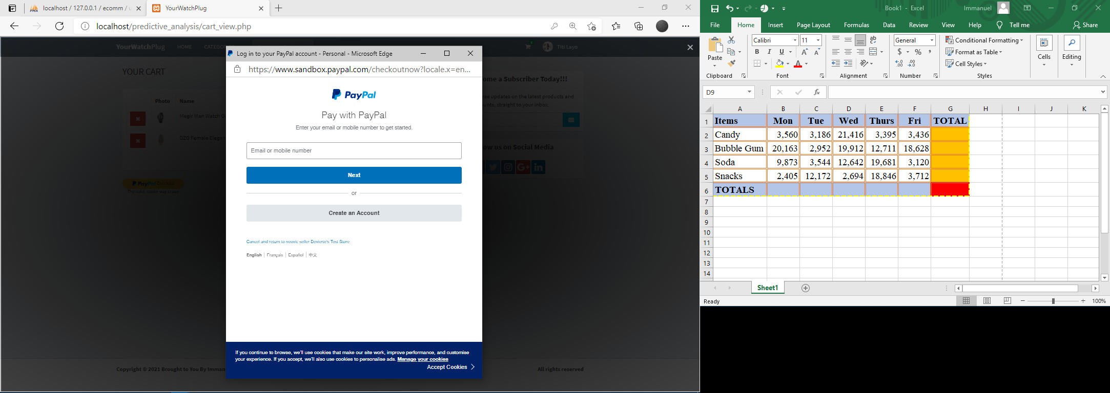

3. The Product Detail Page

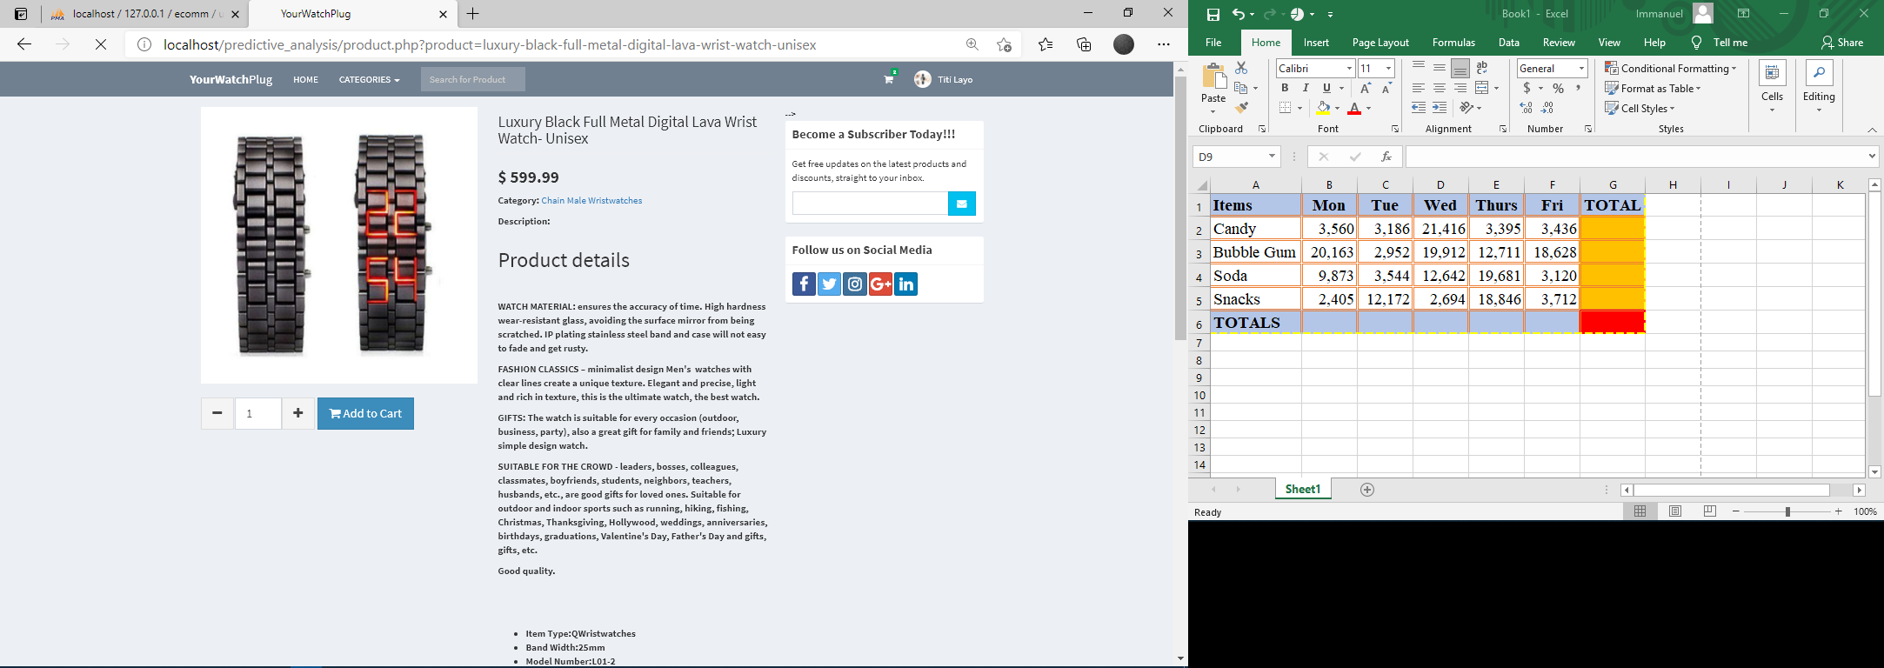

4. The Cart

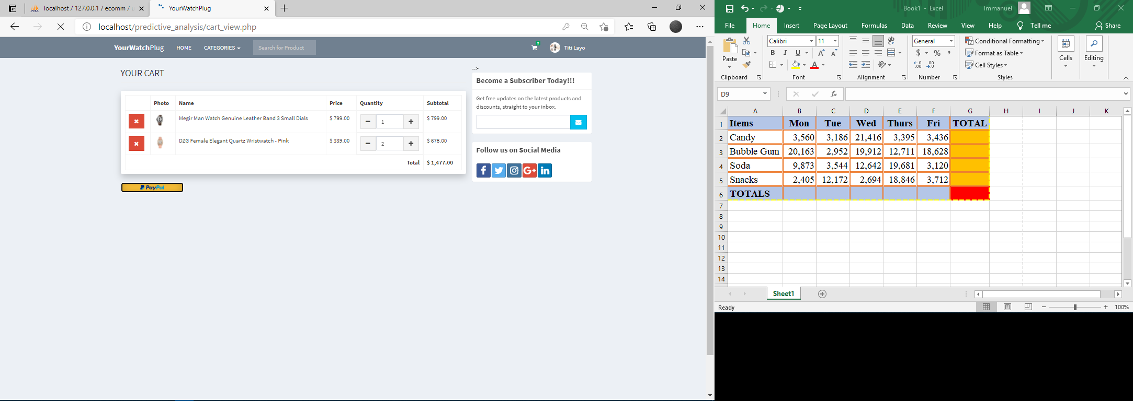

5. The Admin Dashboard

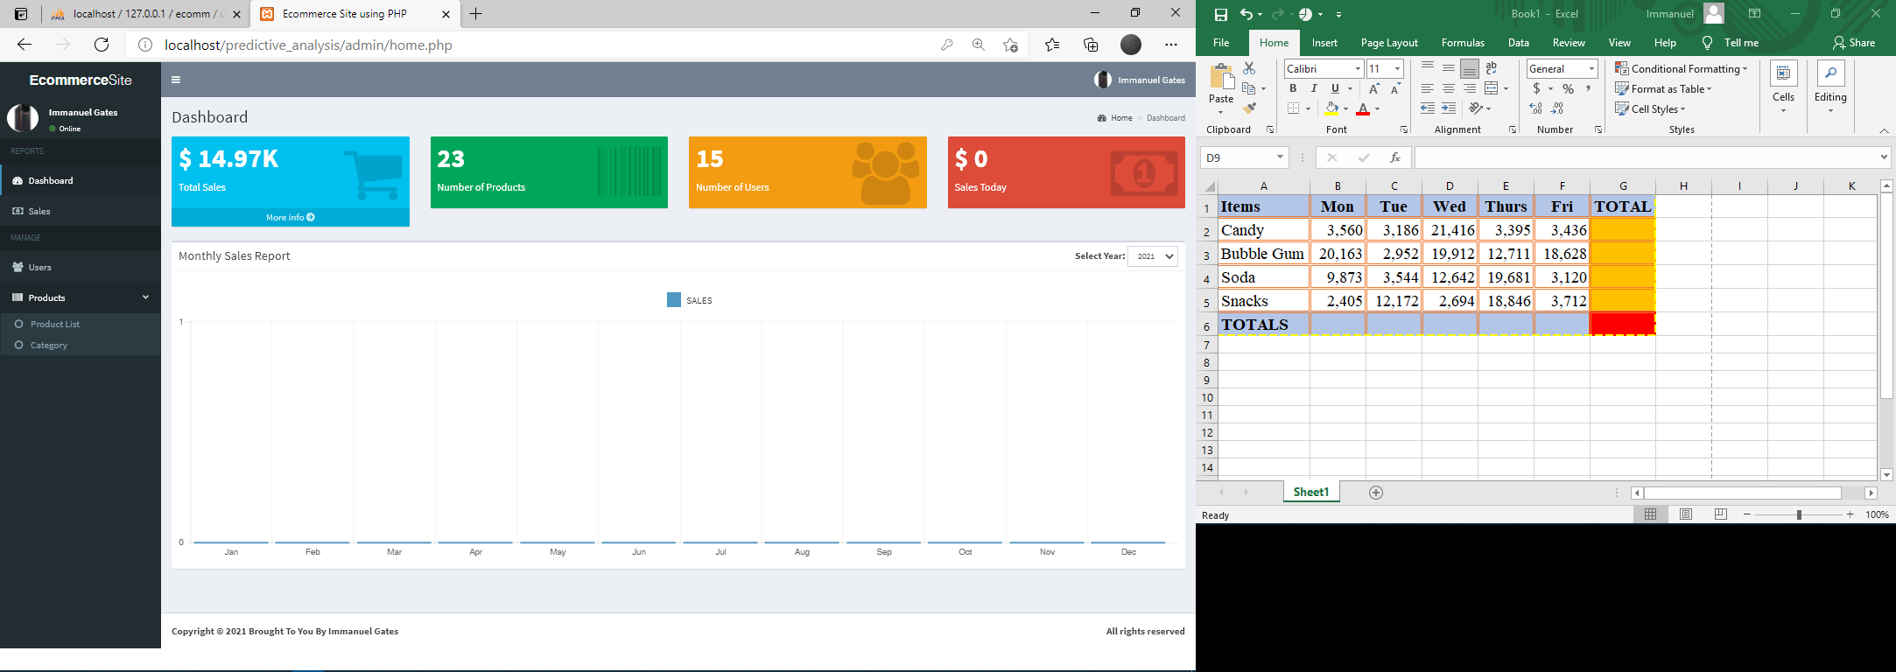

6. Customer Profile

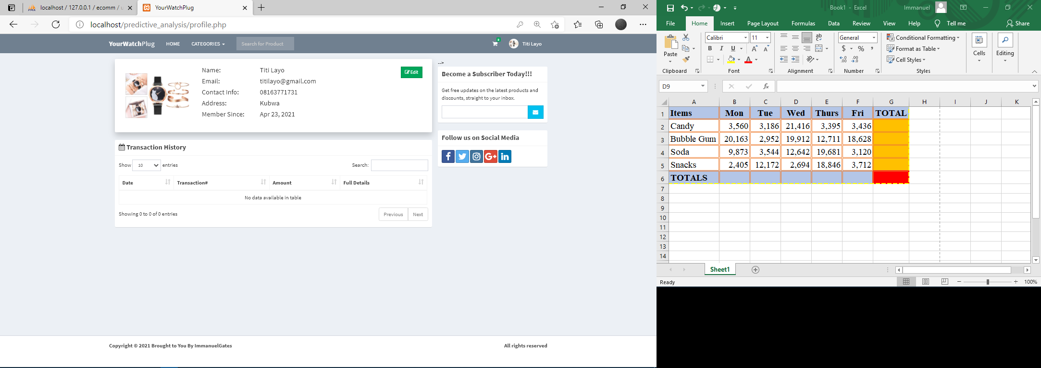

**4.1.3 DATABASE DESIGN**

This refers to the tables used in the proposed system. The database design for the proposed system is as shown below.

Cart

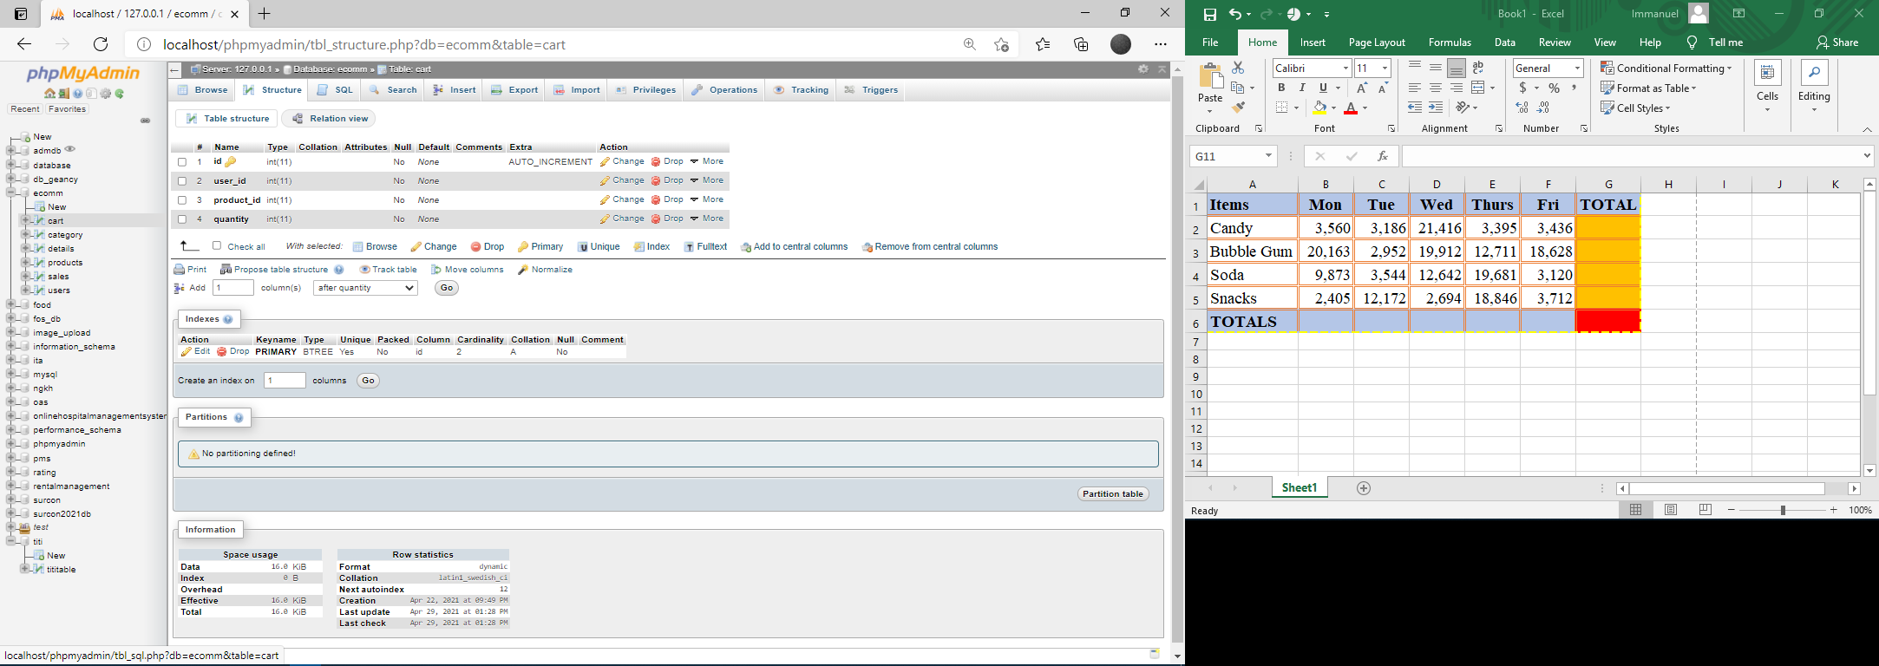

Category

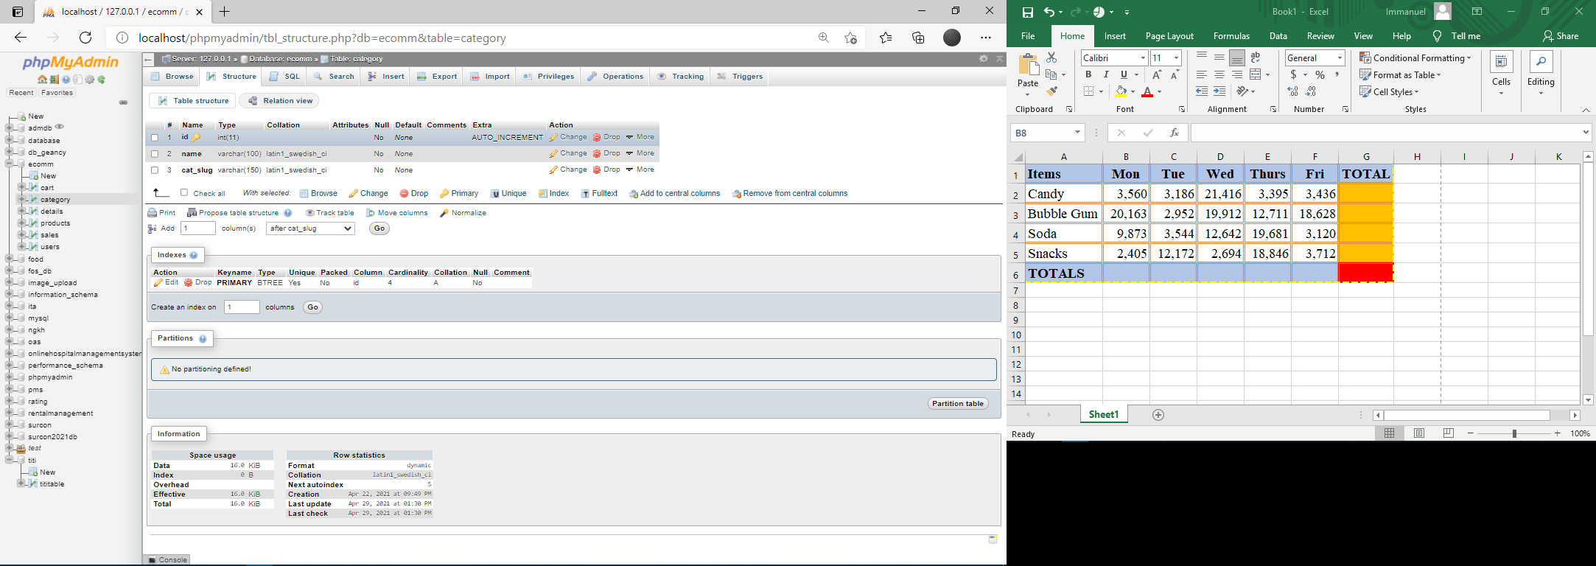

Details

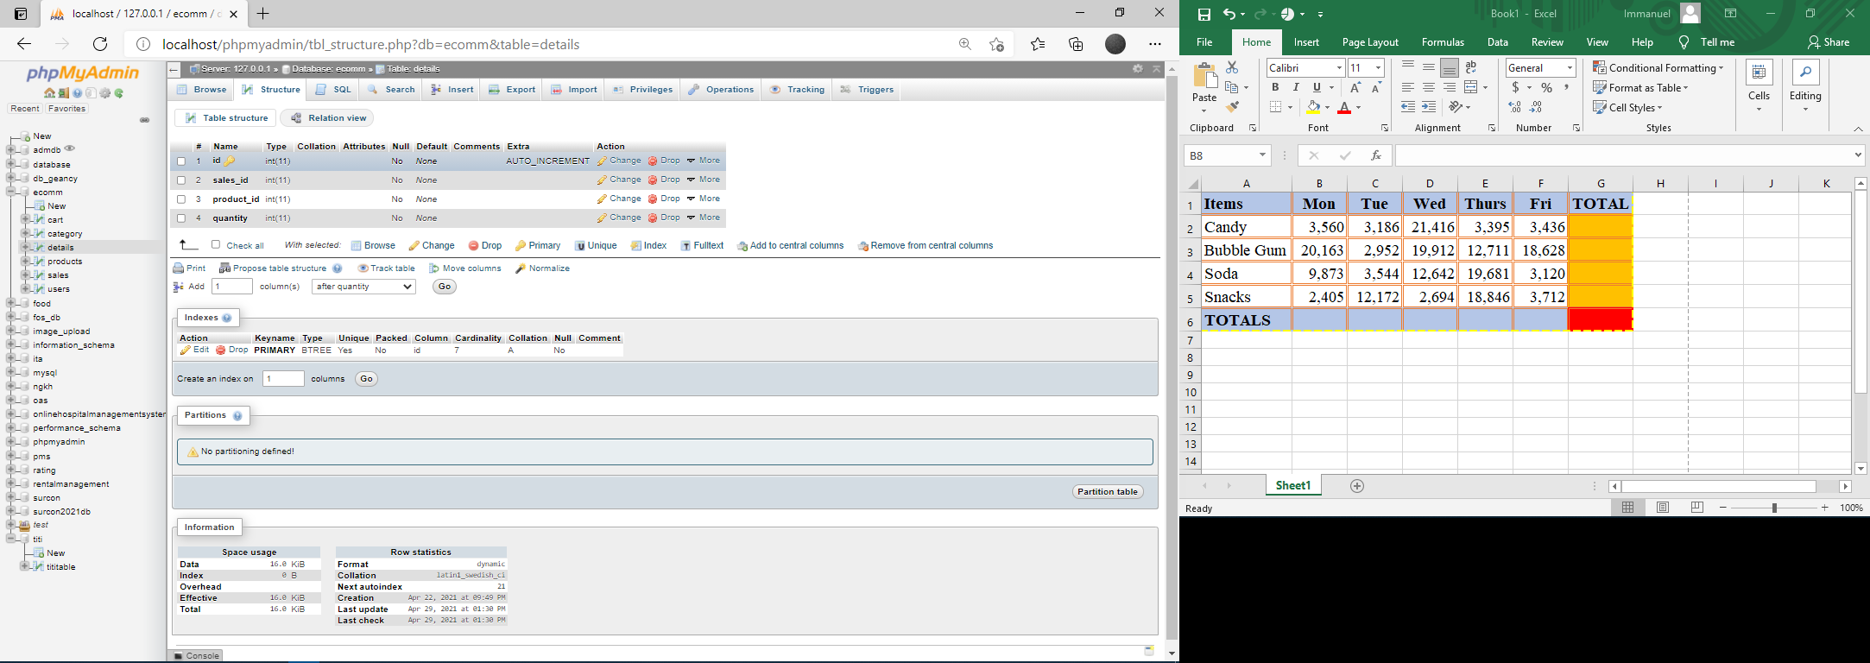

Products

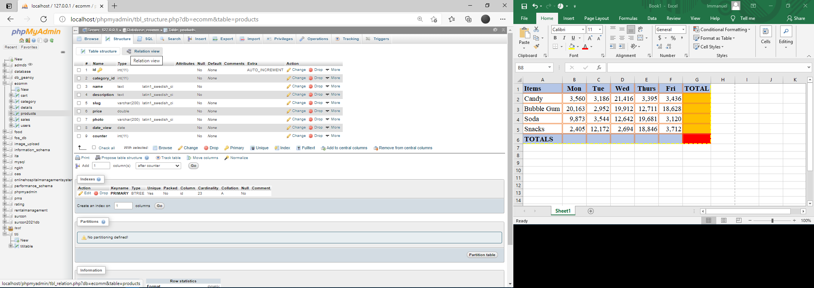

Sales

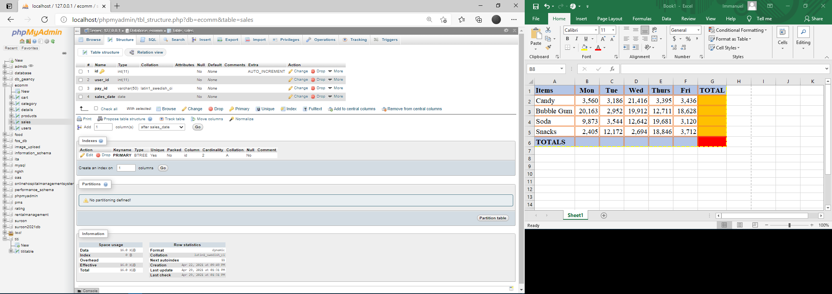

Users  
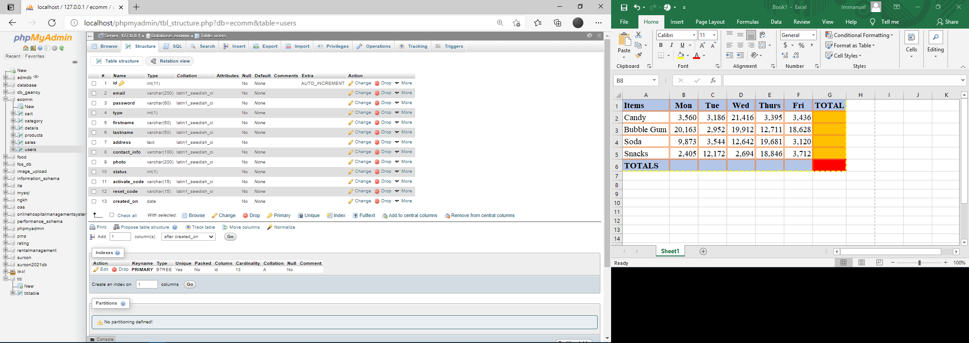

**4.1.4 PROCEDURE DESIGN**

The purposed system made up of various forms, each performing different functions to achieve the goal of the predictive analysis in marketing strategy, which are referenced to from the admin panel.

1. Home page: This is the landing page of the web application where users can view products they are interested in, by categories

2. Admin Dashboard: This is the Admin’s landing page, this is where he oversees the sales performance of each product, the registered users and the products available.

3. The Products Analysis page: This is the page that gives the admin access to identify the product with the most views and the most sold product,

4. The Products Page: This displays details about the selected product, before the product is added to cart

**4.2 IMPLEMENTATION OF THE SYSTEM**

**4.2.1 IMPLEMENTATION TECHNIQUES USED IN DETAILS**

The implementation technique to be used for this research is parallel approach. This means the old and the proposed (new) system will be used interchangeably in order to test for its efficiency, because when a total eradication of the old system is used and the proposed system failed, then it is back to square one for the administrator. Also, a top down procedure is used in system design.

**4.2.2 PROGRAMMING LANGUGE USED**

HTML, CSS PHP, MySQL and JS were used in the development of the system. This application is used because of its flexibility and efficiency as well as the support of Xampp server which is being used for the database system.

**4.2.3 HARDWARE SUPPORT**

The hardware that is require in the successful design and running of this programs include

i. Monitor

ii. Central Processing Unit (CPU)

iii. Keyboard

iv. Mouse

v. Printer

vi. Uninterrupted Power Supply (UPS)

**4.2.4 SOFTWARE SUPPORT**

The software requirement for the design of the proposed system involves:

i. Operating System (Window Xp and its compatibility)

ii. Google Chrome

iii. Xampp server (local host)

**4.3 DOCUMENTATION OF THE SYSTEM.**

**4.3.1 INSTALLING THE PURPOSED** **SYSTEM**

Documentation of the newly designed system is very important before implementation; this is because future demands may call for modification of the programmed development to the care of other areas not included at the inception of the design of the new system.

There are several sub–programs that are written under the main programme and linked to the main programme. Thus, the main programme consist of the following options:

1. User Registration

2. Products Page

3. Cart

4. Admin Dashboard

**4.3.2 USING THE PROPOSED SYSTEM**

The proposed system cannot be installed but can be uploaded into the internet with the requirement of a server (Xampp server) and a password which will be given to the administrator and this will give room for future maintenance of the site.

The designed site can be used using the stated points below:

1. Open a browser e.g., Internet Explorer (Mozilla, fire fox, Netscape, Navigator, Opera etc.

2. Type http:// Localhost/predictive-analysis

3. The home page will be displayed for you to navigate to various parts of the system.

**4.3.3 MAINTAINING THE SYSTEM**

Maintenance can be described as the evaluation and modification of the system. It is done from time to time in other to see whether the system is meeting the goals and providing the services for which it is design.

**CHAPTER FIVE**

**CONCLUSION AND FUTURE SCOPE**

The future of Data Mining lies in Predictive Analytics. This study mainly focuses on opportunities, applications, trends & challenges of Predictive Analytics in Knowledge discovery domain. Predictive Analytics is an area of interest to almost all communities and organizations.

There has been a long history of using predictive models in the tasks of predictions. Earlier, the statistical models were used as the predictive models which were based on the sample data of a large-sized data set. With the improvements in the field of computer science and the advancement of computer techniques, newer techniques have been developed and better and better algorithms been introduced over the period of time. The developments in the field of artificial intelligence and machine learning have changed the world of computation where intelligent computation techniques and algorithms are introduced. The machine learning models have a very well track record of being used as predictive models. Artificial neural networks brought the revolution in the field of predictive analytics. Based on the input parameters, the output or future of any value can be predicted. Now with the advancements in the field of machine learning and the development of deep learning techniques, there is a trend nowadays of using deep learning models in predictive analytics and they are being applied in a full swing in this task. This paper opens a scope of development of new models for the task of predictive analytics. There is also an opportunity to add additional features to the existing models to improve their performance in the task. Predictive analytics is using business intelligence data for forecasting and modeling. Proper data mining algorithms and predictive modeling can refine search for targeted customers. Predictive Analytics can aid in choosing marketing methods, and marketing more efficiently. Predictive Analytics can be also helpful in Social Media Analytics.

References

Andrienko N, Andrienko G, Rinzivillo S (2015) Exploiting spatial abstraction in predictive analytics of vehicle traffic. ISPRS Int J Geo-Inf 4:591–606.  [https://doi.org/10.3390/ijgi4020591CrossRef](https://doi.org/10.3390/ijgi4020591)[Google Scholar](http://scholar.google.com/scholar_lookup?title=Exploiting%20spatial%20abstraction%20in%20predictive%20analytics%20of%20vehicle%20traffic&author=N.%20Andrienko&author=G.%20Andrienko&author=S.%20Rinzivillo&journal=ISPRS%20Int%20J%20Geo-Inf&volume=4&pages=591-606&publication_year=2015&doi=10.3390%2Fijgi4020591)

Balkan S, Demirkan H (n.d) Information services for advanced marketing 10[Google Scholar](https://scholar.google.com/scholar?q=Balkan%20S%2C%20Demirkan%20H%20%28n.d%29%20Information%20services%20for%20advanced%20marketing%2010)

Basha SM, Zhenning Y, Rajput DS, Caytiles RD, Iyengar NCS (2017a) Comparative study on performance analysis of time series predictive models. Int J Grid Distrib Comput 10:37–48.  [https://doi.org/10.14257/ijgdc.2017.10.8.04CrossRef](https://doi.org/10.14257/ijgdc.2017.10.8.04)[Google Scholar](http://scholar.google.com/scholar_lookup?title=Comparative%20Study%20on%20Performance%20Analysis%20of%20Time%20Series%20Predictive%20Models&author=Syed%20Muzamil.%20Basha&author=Yang.%20Zhenning&author=Dharmendra%20Singh.%20Rajput&author=Ronnie%20D..%20Caytiles&author=N.%20Ch.%20S.N.%20Iyengar&journal=International%20Journal%20of%20Grid%20and%20Distributed%20Computing&volume=10&issue=8&pages=37-48&publication_year=2017)

Basha SM, Zhenning Y, Rajput DS, SN, INC, Caytiles RD (2017b) Domain specific predictive analytics: a case study with R. Int J Multimed Ubiquitous Eng 12:13–22[CrossRef](https://doi.org/10.14257/ijmue.2017.12.6.02)[Google Scholar](http://scholar.google.com/scholar_lookup?title=Domain%20Specific%20Predictive%20Analytics%3A%20A%20Case%20Study%20With%20R&author=Syed%20Muzamil.%20Basha&author=Yang.%20Zhenning&author=Dharmendra%20Singh.%20Rajput&author=Iyengar.%20N.Ch.S.N&author=Ronnie%20D..%20Caytiles&journal=International%20Journal%20of%20Multimedia%20and%20Ubiquitous%20Engineering&volume=12&issue=6&pages=15-22&publication_year=2017)

Benoit DF, Van den Poel D (2012) Improving customer retention in financial services using kinship network information. Expert Syst Appl 39:11435–11442.  [https://doi.org/10.1016/j.eswa.2012.04.016CrossRef](https://doi.org/10.1016/j.eswa.2012.04.016)[Google Scholar](http://scholar.google.com/scholar_lookup?title=Improving%20customer%20retention%20in%20financial%20services%20using%20kinship%20network%20information&author=DF.%20Benoit&author=D.%20Poel&journal=Expert%20Syst%20Appl&volume=39&pages=11435-11442&publication_year=2012&doi=10.1016%2Fj.eswa.2012.04.016)

Berecibar M, Devriendt F, Dubarry M, Villarreal I, Omar N, Verbeke W, Van Mierlo J (2016) Online state of health estimation on NMC cells based on predictive analytics. J Power Sources 320:239–250.  [https://doi.org/10.1016/j.jpowsour.2016.04.109CrossRef](https://doi.org/10.1016/j.jpowsour.2016.04.109)[Google Scholar](http://scholar.google.com/scholar_lookup?title=Online%20state%20of%20health%20estimation%20on%20NMC%20cells%20based%20on%20predictive%20analytics&author=M.%20Berecibar&author=F.%20Devriendt&author=M.%20Dubarry&author=I.%20Villarreal&author=N.%20Omar&author=W.%20Verbeke&author=J.%20Mierlo&journal=J%20Power%20Sources&volume=320&pages=239-250&publication_year=2016&doi=10.1016%2Fj.jpowsour.2016.04.109)

Bhalla A (2012) Enhancement in predictive model for insurance underwriting. Eng Technol 3:6[Google Scholar](http://scholar.google.com/scholar_lookup?title=Enhancement%20in%20predictive%20model%20for%20insurance%20underwriting&author=A.%20Bhalla&journal=Eng%20Technol&volume=3&pages=6&publication_year=2012)

Bihani P, Patil ST (2014) A comparative study of data analysis techniques 3:7[Google Scholar](https://scholar.google.com/scholar?q=Bihani%20P%2C%20Patil%20ST%20%282014%29%20A%20comparative%20study%20of%20data%20analysis%20techniques%203%3A7)

Boukenze B, Mousannif H, Haqiq A (2016) Predictive analytics in healthcare system using data mining techniques. Academy & Industry Research Collaboration Center (AIRCC), pp 01–09. <https://doi.org/10.5121/csit.2016.60501>

Gold M, McClarren R, Gaughan C (2013) The lessons Oscar taught Us: data science and media & entertainment. Big Data 1:105–109.  [https://doi.org/10.1089/big.2013.0009CrossRef](https://doi.org/10.1089/big.2013.0009)[Google Scholar](http://scholar.google.com/scholar_lookup?title=The%20lessons%20Oscar%20taught%20Us%3A%20data%20science%20and%20media%20%26%20entertainment&author=M.%20Gold&author=R.%20McClarren&author=C.%20Gaughan&journal=Big%20Data&volume=1&pages=105-109&publication_year=2013&doi=10.1089%2Fbig.2013.0009)

Gotz D, Stavropoulos H, Sun J, Wang F (2012) ICDA: a platform for intelligent care delivery analytics. AMIA Annu Symp Proc 2012:264–273[Google Scholar](http://scholar.google.com/scholar_lookup?title=ICDA%3A%20a%20platform%20for%20intelligent%20care%20delivery%20analytics&author=D.%20Gotz&author=H.%20Stavropoulos&author=J.%20Sun&author=F.%20Wang&journal=AMIA%20Annu%20Symp%20Proc&volume=2012&pages=264-273&publication_year=2012)

Gregus M, Kryvinska N (2015) Service orientation of enterprises—aspects, dimensions, technologies. Comenius University in Bratislava. ISBN: 9788022339780[Google Scholar](https://scholar.google.com/scholar?q=Gregus%20M%2C%20Kryvinska%20N%20%282015%29%20Service%20orientation%20of%20enterprises%E2%80%94aspects%2C%20dimensions%2C%20technologies.%20Comenius%20University%20in%20Bratislava.%20ISBN%3A%209788022339780)

Guidi G, Miniati R, Mazzola M, Iadanza E (2016) Case study: IBM watson analytics cloud platform as analytics-as-a-service system for heart failure early detection. Future Internet 8:32.  [https://doi.org/10.3390/fi8030032CrossRef](https://doi.org/10.3390/fi8030032)[Google Scholar](http://scholar.google.com/scholar_lookup?title=Case%20study%3A%20IBM%20watson%20analytics%20cloud%20platform%20as%20analytics-as-a-service%20system%20for%20heart%20failure%20early%20detection&author=G.%20Guidi&author=R.%20Miniati&author=M.%20Mazzola&author=E.%20Iadanza&journal=Future%20Internet&volume=8&pages=32&publication_year=2016&doi=10.3390%2Ffi8030032)

Halim MIA, Hashim W, Ismail AF, Suliman SH, Yahya AS, Raj RMA (2018) Evaluating predictive analytics model performance accuracy for network selection mechanism. J Fundam Appl Sci 10:162–172[Google Scholar](http://scholar.google.com/scholar_lookup?title=Evaluating%20predictive%20analytics%20model%20performance%20accuracy%20for%20network%20selection%20mechanism&author=MIA.%20Halim&author=W.%20Hashim&author=AF.%20Ismail&author=SH.%20Suliman&author=AS.%20Yahya&author=RMA.%20Raj&journal=J%20Fundam%20Appl%20Sci&volume=10&pages=162-172&publication_year=2018)

Hanumanthappa DM (2011) Predicting the future of car manufacturing industry using data mining. Techniques 01:3[Google Scholar](http://scholar.google.com/scholar_lookup?title=Predicting%20the%20future%20of%20car%20manufacturing%20industry%20using%20data%20mining&author=DM.%20Hanumanthappa&journal=Techniques&volume=01&pages=3&publication_year=2011)

Harvey A, Luckman M (2014) Beyond demographics: predicting student attrition within the bachelor of arts degree. Int J First Year High Educ 5.  <https://doi.org/10.5204/intjfyhe.v5i1.187>

Hashimzade N, Myles G (2017) Risk-based audits in a behavioral model. Public Financ Rev 45:140–165.  [https://doi.org/10.1177/1091142115602062CrossRef](https://doi.org/10.1177/1091142115602062)[Google Scholar](http://scholar.google.com/scholar_lookup?title=Risk-based%20audits%20in%20a%20behavioral%20model&author=N.%20Hashimzade&author=G.%20Myles&journal=Public%20Financ%20Rev&volume=45&pages=140-165&publication_year=2017&doi=10.1177%2F1091142115602062)

Hashimzade N, Myles GD, Rablen MD (2016) Predictive analytics and the targeting of audits. J Econ Behav Org Tax Soc Norms Compliance 124:130–145.  [https://doi.org/10.1016/j.jebo.2015.11.009CrossRef](https://doi.org/10.1016/j.jebo.2015.11.009)[Google Scholar](http://scholar.google.com/scholar_lookup?title=Predictive%20analytics%20and%20the%20targeting%20of%20audits&author=N.%20Hashimzade&author=GD.%20Myles&author=MD.%20Rablen&journal=J%20Econ%20Behav%20Org%20Tax%20Soc%20Norms%20Compliance&volume=124&pages=130-145&publication_year=2016&doi=10.1016%2Fj.jebo.2015.11.009)

Jacob MSG (n.d) Discovery of knowledge patterns in clinical data through data mining algorithms: multi-class categorization of breast tissue data. Int J Comput Appl 32:8[Google Scholar](https://scholar.google.com/scholar?q=Jacob%20MSG%20%28n.d%29%20Discovery%20of%20knowledge%20patterns%20in%20clinical%20data%20through%20data%20mining%20algorithms%3A%20multi-class%20categorization%20of%20breast%20tissue%20data.%20Int%20J%20Comput%20Appl%2032%3A8)

Kaczor S, Kryvinska N (2013) It is all about services—fundamentals, drivers, and business models. Soc Serv Sci J Serv Sci Res 5(2):125–154[CrossRef](https://doi.org/10.1007/s12927-013-0004-y)[Google Scholar](http://scholar.google.com/scholar_lookup?title=It%20is%20all%20about%20services%E2%80%94fundamentals%2C%20drivers%2C%20and%20business%20models&author=S.%20Kaczor&author=N.%20Kryvinska&journal=Soc%20Serv%20Sci%20J%20Serv%20Sci%20Res&volume=5&issue=2&pages=125-154&publication_year=2013)

Kapoor B, Sherif J (2012) Global human resources (HR) information systems. Kybernetes 41:229–238[CrossRef](https://doi.org/10.1108/03684921211213052)[Google Scholar](http://scholar.google.com/scholar_lookup?title=Global%20human%20resources%20%28HR%29%20information%20systems&author=B.%20Kapoor&author=J.%20Sherif&journal=Kybernetes&volume=41&pages=229-238&publication_year=2012)

Khan SS, Quadri SMK (n.d) Prediction of angiographic disease status using rule based data mining techniques. 5[Google Scholar](https://scholar.google.com/scholar?q=Khan%20SS%2C%20Quadri%20SMK%20%28n.d%29%20Prediction%20of%20angiographic%20disease%20status%20using%20rule%20based%20data%20mining%20techniques.%205)

Klindworth WA (n.d) Assessment of predictive modeling for identifying fraud within the medicare program. 29[Google Scholar](https://scholar.google.com/scholar?q=Klindworth%20WA%20%28n.d%29%20Assessment%20of%20predictive%20modeling%20for%20identifying%20fraud%20within%20the%20medicare%20program.%2029)

Kraljević G, Gotovac S (2010) Modeling data mining applications for prediction of prepaid churn in telecommunication services. Automatika 51:275–283.  [https://doi.org/10.1080/00051144.2010.11828381CrossRef](https://doi.org/10.1080/00051144.2010.11828381)[Google Scholar](http://scholar.google.com/scholar_lookup?title=Modeling%20data%20mining%20applications%20for%20prediction%20of%20prepaid%20churn%20in%20telecommunication%20services&author=G.%20Kraljevi%C4%87&author=S.%20Gotovac&journal=Automatika&volume=51&pages=275-283&publication_year=2010&doi=10.1080%2F00051144.2010.11828381)

Kryvinska N, Olexova R, Dohmen P, Strauss C (2013) The S-D logic phenomenon—conceptualization and systematization by reviewing the literature of a decade (2004–2013). Soc Serv Sci J Serv Sci Res 5(1):35–94 Springer[CrossRef](https://doi.org/10.1007/s12927-013-0002-0)[Google Scholar](http://scholar.google.com/scholar_lookup?title=The%20S-D%20logic%20phenomenon%E2%80%94conceptualization%20and%20systematization%20by%20reviewing%20the%20literature%20of%20a%20decade%20%282004%E2%80%932013%29&author=N.%20Kryvinska&author=R.%20Olexova&author=P.%20Dohmen&author=C.%20Strauss&journal=Soc%20Serv%20Sci%20J%20Serv%20Sci%20Res&volume=5&issue=1&pages=35-94&publication_year=2013)

Kryvinska N (2012) Building consistent formal specification for the service enterprise agility foundation. Soc Serv Sci J Serv Sci Res 4(2):235–269[CrossRef](https://doi.org/10.1007/s12927-012-0010-5)[Google Scholar](http://scholar.google.com/scholar_lookup?title=Building%20consistent%20formal%20specification%20for%20the%20service%20enterprise%20agility%20foundation&author=N.%20Kryvinska&journal=Soc%20Serv%20Sci%20J%20Serv%20Sci%20Res&volume=4&issue=2&pages=235-269&publication_year=2012)

Kryvinska N, Gregus M (2014) SOA and its business value in requirements, features, practices and methodologies. Comenius University in Bratislava. ISBN: 9788022337649[Google Scholar](https://scholar.google.com/scholar?q=Kryvinska%20N%2C%20Gregus%20M%20%282014%29%20SOA%20and%20its%20business%20value%20in%20requirements%2C%20features%2C%20practices%20and%20methodologies.%20Comenius%20University%20in%20Bratislava.%20ISBN%3A%209788022337649)

Kumar NMS, Eswari T, Sampath P, Lavanya S (2015) Predictive methodology for diabetic data analysis in big data. Procedia Comput Sci Big Data Cloud Comput Chall 50:203–208.  [https://doi.org/10.1016/j.procs.2015.04.069CrossRef](https://doi.org/10.1016/j.procs.2015.04.069)[Google Scholar](http://scholar.google.com/scholar_lookup?title=Predictive%20methodology%20for%20diabetic%20data%20analysis%20in%20big%20data&author=NMS.%20Kumar&author=T.%20Eswari&author=P.%20Sampath&author=S.%20Lavanya&journal=Procedia%20Comput%20Sci%20Big%20Data%20Cloud%20Comput%20Chall&volume=50&pages=203-208&publication_year=2015&doi=10.1016%2Fj.procs.2015.04.069)

Lee J, Kao H-A, Yang S (2014) Service innovation and smart analytics for industry 4.0 and big data environment. procedia CIRP, product services systems and value creation. In: Proceedings of the 6th CIRP conference on industrial product-service systems, vol 16, pp 3–8.  [https://doi.org/10.1016/j.procir.2014.02.001CrossRef](https://doi.org/10.1016/j.procir.2014.02.001)[Google Scholar](http://scholar.google.com/scholar_lookup?title=Service%20Innovation%20and%20Smart%20Analytics%20for%20Industry%204.0%20and%20Big%20Data%20Environment&author=Jay.%20Lee&author=Hung-An.%20Kao&author=Shanhu.%20Yang&journal=Procedia%20CIRP&volume=16&pages=3-8&publication_year=2014)

Lee J, Lapira E, Yang S, Kao A (2013) Predictive manufacturing system—trends of next-generation production systems. In: IFAC proceedings, vol 46, pp 150–156.  [https://doi.org/10.3182/20130522-3-BR-4036.00107CrossRef](https://doi.org/10.3182/20130522-3-BR-4036.00107)[Google Scholar](http://scholar.google.com/scholar_lookup?title=Predictive%20Manufacturing%20System%20-%20Trends%20of%20Next-Generation%20Production%20Systems&author=Jay.%20Lee&author=Edzel.%20Lapira&author=Shanhu.%20Yang&author=Ann.%20Kao&journal=IFAC%20Proceedings%20Volumes&volume=46&issue=7&pages=150-156&publication_year=2013)

Li X, Xie H, Song Y, Zhu S, Li Q, Wang FL (2015) Does summarization help stock prediction? a news impact analysis. IEEE Intell Syst 30:26–34.  [https://doi.org/10.1109/MIS.2015.1CrossRef](https://doi.org/10.1109/MIS.2015.1)[Google Scholar](http://scholar.google.com/scholar_lookup?title=Does%20summarization%20help%20stock%20prediction%3F%20a%20news%20impact%20analysis&author=X.%20Li&author=H.%20Xie&author=Y.%20Song&author=S.%20Zhu&author=Q.%20Li&author=FL.%20Wang&journal=IEEE%20Intell%20Syst&volume=30&pages=26-34&publication_year=2015&doi=10.1109%2FMIS.2015.1)

Liu S, Shen Z, Mei J, Ji J (2013) Parkinson’s disease predictive analytics through a pad game based on personal data 19:17[Google Scholar](https://scholar.google.com/scholar?q=Liu%20S%2C%20Shen%20Z%2C%20Mei%20J%2C%20Ji%20J%20%282013%29%20Parkinson%E2%80%99s%20disease%20predictive%20analytics%20through%20a%20pad%20game%20based%20on%20personal%20data%2019%3A17)

Mishra D (2010) Predictive data mining: promising future and applications, 2:9[Google Scholar](https://scholar.google.com/scholar?q=Mishra%20D%20%282010%29%20Predictive%20data%20mining%3A%20promising%20future%20and%20applications%2C%202%3A9)

Ng K, Ghoting A, Steinhubl SR, Stewart WF, Malin B, Sun J (2014) PARAMO: a PARAllel predictive MOdeling platform for healthcare analytic research using electronic health records. J Biomed Inform 48:160–170.  [https://doi.org/10.1016/j.jbi.2013.12.012CrossRef](https://doi.org/10.1016/j.jbi.2013.12.012)[Google Scholar](http://scholar.google.com/scholar_lookup?title=PARAMO%3A%20a%20PARAllel%20predictive%20MOdeling%20platform%20for%20healthcare%20analytic%20research%20using%20electronic%20health%20records&author=K.%20Ng&author=A.%20Ghoting&author=SR.%20Steinhubl&author=WF.%20Stewart&author=B.%20Malin&author=J.%20Sun&journal=J%20Biomed%20Inform&volume=48&pages=160-170&publication_year=2014&doi=10.1016%2Fj.jbi.2013.12.012)

Renjith S (2015) An integrated framework to recommend personalized retention actions to control B2C E-commerce customer churn. Int J Eng Trends Technol 27:152–157.  [https://doi.org/10.14445/22315381/IJETT-V27P227CrossRef](https://doi.org/10.14445/22315381/IJETT-V27P227)[Google Scholar](http://scholar.google.com/scholar_lookup?title=An%20integrated%20framework%20to%20recommend%20personalized%20retention%20actions%20to%20control%20B2C%20E-commerce%20customer%20churn&author=S.%20Renjith&journal=Int%20J%20Eng%20Trends%20Technol&volume=27&pages=152-157&publication_year=2015&doi=10.14445%2F22315381%2FIJETT-V27P227)

Shameer K, Johnson KW, Yahi A, Miotto R, Li LI, Ricks D, Jebakaran J, Kovatch P, Sengupta PP, Gelijns S (2017) Predictive modeling of hospital readmission rates using electronic medical record-wide machine learning: a case-study using mount sinai heart failure cohort. In: Pacific symposium on biocomputing 2017. World Scientific, pp 276–287[Google Scholar](https://scholar.google.com/scholar?q=Shameer%20K%2C%20Johnson%20KW%2C%20Yahi%20A%2C%20Miotto%20R%2C%20Li%20LI%2C%20Ricks%20D%2C%20Jebakaran%20J%2C%20Kovatch%20P%2C%20Sengupta%20PP%2C%20Gelijns%20S%20%282017%29%20Predictive%20modeling%20of%20hospital%20readmission%20rates%20using%20electronic%20medical%20record-wide%20machine%20learning%3A%20a%20case-study%20using%20mount%20sinai%20heart%20failure%20cohort.%20In%3A%20Pacific%20symposium%20on%20biocomputing%202017.%20World%20Scientific%2C%20pp%20276%E2%80%93287)

Shams I, Ajorlou S, Yang K (2015) A predictive analytics approach to reducing 30-day avoidable readmissions among patients with heart failure, acute myocardial infarction, pneumonia, or COPD. Health Care Manag Sci 18:19–34. [https://doi.org/10.1007/s10729-014-9278-yCrossRef](https://doi.org/10.1007/s10729-014-9278-y)[Google Scholar](http://scholar.google.com/scholar_lookup?title=A%20predictive%20analytics%20approach%20to%20reducing%2030-day%20avoidable%20readmissions%20among%20patients%20with%20heart%20failure%2C%20acute%20myocardial%20infarction%2C%20pneumonia%2C%20or%20COPD&author=Issac.%20Shams&author=Saeede.%20Ajorlou&author=Kai.%20Yang&journal=Health%20Care%20Management%20Science&volume=18&issue=1&pages=19-34&publication_year=2014)

Sridhar P, Dharmaji N (n.d) A comparative study on how big data is scaling business intelligence and analytics, 2:10[Google Scholar](https://scholar.google.com/scholar?q=Sridhar%20P%2C%20Dharmaji%20N%20%28n.d%29%20A%20comparative%20study%20on%20how%20big%20data%20is%20scaling%20business%20intelligence%20and%20analytics%2C%202%3A10)

Upendran D, Chatterjee S, Sindhumol S, Bijlani K (2016) Application of predictive analytics in intelligent course recommendation. Procedia Comput Sci 93:917–923.  [https://doi.org/10.1016/j.procs.2016.07.267CrossRef](https://doi.org/10.1016/j.procs.2016.07.267)[Google Scholar](http://scholar.google.com/scholar_lookup?title=Application%20of%20predictive%20analytics%20in%20intelligent%20course%20recommendation&author=D.%20Upendran&author=S.%20Chatterjee&author=S.%20Sindhumol&author=K.%20Bijlani&journal=Procedia%20Comput%20Sci&volume=93&pages=917-923&publication_year=2016&doi=10.1016%2Fj.procs.2016.07.267)

Wang Y (2013) A proactive complex event processing method for intelligent transportation systems. Lect Notes Inf Theory 1:109–113.  [https://doi.org/10.12720/lnit.1.3.109-113CrossRef](https://doi.org/10.12720/lnit.1.3.109-113)[Google Scholar](http://scholar.google.com/scholar_lookup?title=A%20proactive%20complex%20event%20processing%20method%20for%20intelligent%20transportation%20systems&author=Y.%20Wang&journal=Lect%20Notes%20Inf%20Theory&volume=1&pages=109-113&publication_year=2013&doi=10.12720%2Flnit.1.3.109-113)

Wang Y, Gao H, Chen G (2018) Predictive complex event processing based on evolving Bayesian networks. Pattern Recognit Lett Mach Learn Appl Artif Intell 105:207-216. [https://doi.org/10.1016/j.patrec.2017.05.008CrossRef](https://doi.org/10.1016/j.patrec.2017.05.008)[Google Scholar](http://scholar.google.com/scholar_lookup?title=Predictive%20complex%20event%20processing%20based%20on%20evolving%20Bayesian%20networks&author=Y.%20Wang&author=H.%20Gao&author=G.%20Chen&journal=Pattern%20Recognit%20Lett%20Mach%20Learn%20Appl%20Artif%20Intell&volume=105&pages=207-216&publication_year=2018&doi=10.1016%2Fj.patrec.2017.05.008)

Zhang W, Li C, Ye Y, Li W, Ngai EWT (2015) Dynamic business network analysis for correlated stock price movement prediction. IEEE Intell Syst 30:26–33.  [https://doi.org/10.1109/MIS.2015.25CrossRef](https://doi.org/10.1109/MIS.2015.25)[Google Scholar](http://scholar.google.com/scholar_lookup?title=Dynamic%20business%20network%20analysis%20for%20correlated%20stock%20price%20movement%20prediction&author=W.%20Zhang&author=C.%20Li&author=Y.%20Ye&author=W.%20Li&author=EWT.%20Ngai&journal=IEEE%20Intell%20Syst&volume=30&pages=26-33&publication_year=2015&doi=10.1109%2FMIS.2015.25)

Zhu X, Kui F, Wang Y (2013) Predictive analytics by using bayesian model averaging for large-scale internet of things. Int J Distrib Sens Netw 9:723260.  [https://doi.org/10.1155/2013/723260CrossRef](https://doi.org/10.1155/2013/723260)[Google Scholar](http://scholar.google.com/scholar_lookup?title=Predictive%20analytics%20by%20using%20bayesian%20model%20averaging%20for%20large-scale%20internet%20of%20things&author=X.%20Zhu&author=F.%20Kui&author=Y.%20Wang&journal=Int%20J%20Distrib%20Sens%20Netw&volume=9&pages=723260&publication_year=2013&doi=10.1155%2F2013%2F723260)

F Reichheld, P Schefter, Retrieved 2018, “The Economics

of E-Loyalty”, Harvard Business School Working

Knowledge.

V Dhar, 2001, “Predictions in Financial Markets: The Case of Small Disjuncts”, ACM Transaction on Intelligent Systems and Technology, Vol-2, Issue-3.

J Osheroff, J Teich, B Middleton, E Steen, A Wright, D Detmer, 2007, “A Roadmap for National Action on Clinical Decision Support”, JAMIA: A Scholarly Journal of Informatics in Health and Biomedicine, Vol-14, Issue-2, Pages-141-145.

B Kaminski, M Jakubczyk, P Szufel, 2018, “A framework for sensitivity analysis of decision trees”, Central European Journal of Operations Research, Vol- 26, Issue-1, Pages-135-159.

J S Armstrong, 2012, “Illusions in regression analysis”, International Journal of Forecasting, Vol-28, Issue-3, Pages-689-694.

W S McCulloch, Walter Pitts, 1943, “A logical calculus of the ideas immanent in nervous activities”, The bulletin of mathematical biophysics, Vol-5, Issue-4, Pages-115-133.

Peter M Lee, 2012, “Bayesian Statistics: An Introduction, 4th Edition”, John Willey and Sons Ltd.

R Polikar, 2006, “Ensemble based Systems in decision making”, IEEE Circuits and Systems Magazine, Vol-6, Issue-3, Pages-21-45.

J H Friedman, 1999, “Greedy Function Approximation: A Gradient Boosting Machine”, Lecture notes. C Cortes, 1995, “Support-vector networks”, Machine Learning, Vol-20, Issue-3, Pages- 273-297.

Ben Hur et al, 2001, “Support Vector Clustering”, Journal of Machine Learning Research, Vol-2, Pages-125-137.

J Lin, E Keogh, S Lonardi, C Chiu, 2003, “A symbolic representation of time series, with implications for streaming algorithms”, Proceedings of the 8th ACM SIGMOD workshop on research issues in data mining and knowledge discovery, Pages-2-11.

N S Altman, 1992, “An Introduction to Kernel and Nearest-Neighbor Nonparametric Regression”, The American Statistician, Vol-46, Issue-3, Pages- 175-185.

H Abdi, L J Williams, 2010, “Principal component analysis”, WIREs: Computational Statistics, Vol-2, Issue-4, Pages-433-459.

K Das, GS Vidyashankar, 2006, “Competitive Advantage in Retail Through Analytics: Developing Insights, Creating Values”, Information Management.

N Conz, 2008, “Insurers Shift to Customer-Focused Predictive Analytics Technologies”, Insurance & Technology.